A Project Report
On

SECURITY IN CLOUD COMPUTING

Submitted in Partial Fulfillment of the Requirements for the Award of

The Degree of

Bachelor of Technology in

Computer Science and Engineering
By

SANJEEV KUMAR (1406027)

RAHUL KUMAR (1406010)

UDITA BHARTI (1406088)

SARASWATI (1406050)

Under the Supervision of:

Dr. Ditipriya Sinha


DEPARTMENT OF COMPUTER SCIENCE & ENGINEERING NATIONAL INSTITUTE OF TECHNOLOGY PATNA
Jan-Jul 2017

DECLARATION

We hereby declare that this project work entitled “Security in cloud

computing” has been carried out by us in the Department of Computer

Science and Engineering of National Institute of Technology Patna

under the guidance of Dr. Ditipriya Sinha, Assistant Professor,

Department of Computer Science and Engineering, NIT Patna. No part

of this work has already been developed for the award of degree or

diploma to this institute.

Place: Patna | SANJEEV KUMAR
Date: 8-May-2017 | RAHUL KUMAR
 | UDITA BHARTI
 | SARASWATI



CERTIFICATE

This is to certify that Rahul Kumar(Roll no. 1406010), Sanjeev Kumar(Roll no. 1406027), Udita Bharti(Roll no. 1406088) & Saraswati(Roll no. 1406050) have carried out the project entitled “Security in Cloud Computing” as their 6th semester project under the supervision of Dr. Ditipriya Sinha, Assistant Professor, Computer Science and Engineering Department. This project report is the bona fide work done by them for the partial fulfillment of the requirements for the award of the degree of B. Tech. in Computer Science & Engineering.

Dr. Ditipriya Sinha | Dr. Prabhat Kumar
(Project Guide) | Assistant Professor &
Assistant Professor | Head of Department
Department of | Computer Science &
Computer Science & | Engineering
Engineering

ACKNOWLEDGEMENT

We would like to express our deepest gratitude towards our project mentor Dr. Ditipriya Sinha (Computer Science and Engineering, NIT Patna) for his valuable suggestions, insightful criticisms and directions throughout the development of the project. He has always encouraged us to get out of the shell and do something innovative despite our limitations.

We further express our gratitude to our Head of the Department, Dr. Prabhat Kumar for being a constant source of inspiration. We are also thankful to all the non-teaching staff of the Department of Computer Science and Engineering, NIT Patna for their support. Finally, we thank our friends and family members for providing constant encouragement, support and valuable suggestions during the development of the project.

Sanjeev Kumar(1406027)
Rahul Kumar(1406010)
Udita Bharti(1406088)
Saraswati(1406050)

Table Of Contents

- Introduction II. Objective

III. Related Works

IV. Proposed Approach V. Software Requirement VI. Work Done

VII. Result

VIII. Future Work IX. Conclusion
X. References

I. INTRODUCTION

Today we are using Cloud Computing everywhere.Most of companies either big or small all are using Cloud Computing either for storage of their data or for providing services .Some real world application of cloud computing are:-

 Business requirements:- Netflix, Adobe connect, Expense reporting, Timesheet, Payroll systems
- Email-Communication.

- Backup Services.

- Banking and Financial Services.

- Social Networking:- Facebook, LinkedIn, MySpace

- Improved Communications

- Hospitals And Health-Care Databases

Cloud computing security is the set of control-based technologies and policies designed to adhere to regulatory compliance rules and protect information, data applications and infrastructure associated with cloud computing use. Cloud computing security processes should address the security controls the cloud provider will incorporate to maintain the
Customer’s data security, privacy and compliance with necessary regulations.

II. PROBLEM STATEMENT AND OBJECTIVE

Case I : In Single Group environment we have to design and analyze an algorithm for efficient computation and distribution of key

Case II : In Multi Group environment we have to design and analyze an algorithm for efficient computation of key for secure communication.

III. RELATED WORK

A Dynamic Secure Group Sharing Framework in Public Cloud Computing, IEEE Transaction on Cloud Computing, 2014.

- They have enhanced the Tree-Based Group Diffie-Hellman (TGDH), with the help of cloud server and supports the group key pairs negotiate and update the group key pairs even though not all of the group members are online together.

- This method is preserving the privacy by supporting the updation of the group key pair whenever group member’s joining or leaving.

- The drawback of this method is they used a large number of dummy nodes in tree construction and group key computation.

A Tree Key Graph Design Scheme for Hierarchical Multi-Group Access Control

- For a hierarchical multi-group access control mechanism that is utilizing group keys and tree key graph, and has lower rekeying overhead, They propose a tree key graph design scheme.

- Digital broadcasting television, internet protocol television or digital multimedia broadcasting system needs group access control mechanism to provide a hierarchical multi-group access privileges for its channel resources
 

- The drawback of this approach is that there is a high computation work and it take more time for key computation which is not affodable in Real time Applications.

IV. PROPOSED APPROACH

In our approach we have enhanced Tree Based Group Diffie-Hellman Algorithm.

It maintain three basic properties:

- Forward Secrecy:- when new member join the group then that member will get access to all information.

- Backward Secracy:- when a member leave the group then that member is not able to access the information.
- Distributive property:-each member has some contribution in generation key.

IV.1 Proposed Approach for Single Group Environment

It consists of three phases:

- Group Initialization

- Group Key Management

- Intra- and Inter-Group Secure Data Sharing

- In Group Initialization phase we generate a complete binary tree. Each node is a member group.

- We can create complete binary tree either using offline algorithm or online algorithm. but in our scenario we are using offline algorithm. We are using queue data to construct complete binary tree.
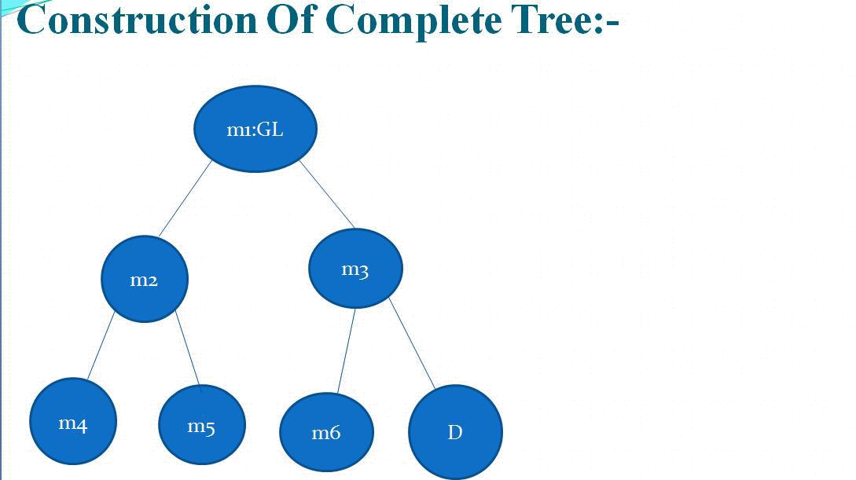

Key Generation

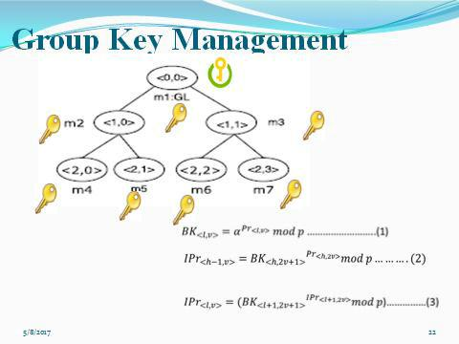

- In Group Key Management we are generating blind key and Intermediate key and ultimately Group key using algorithm described above.

- When a new member join a group then re computation of key take place in this way it preserves forward secrecy property.

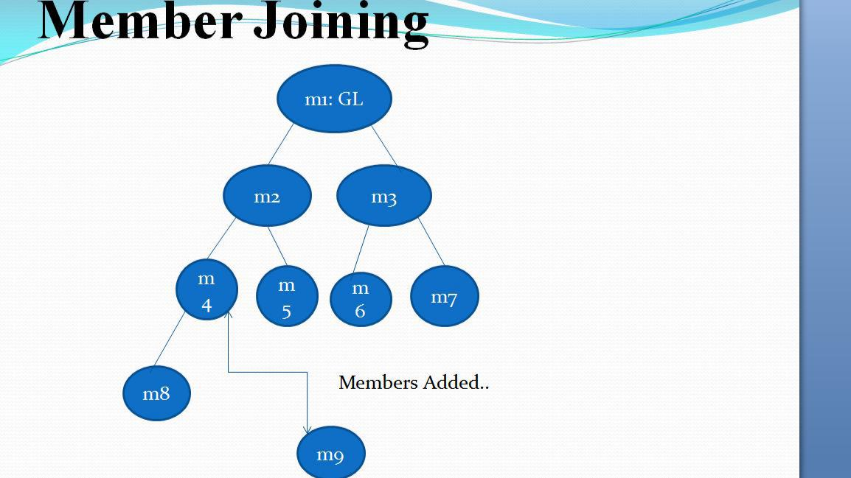

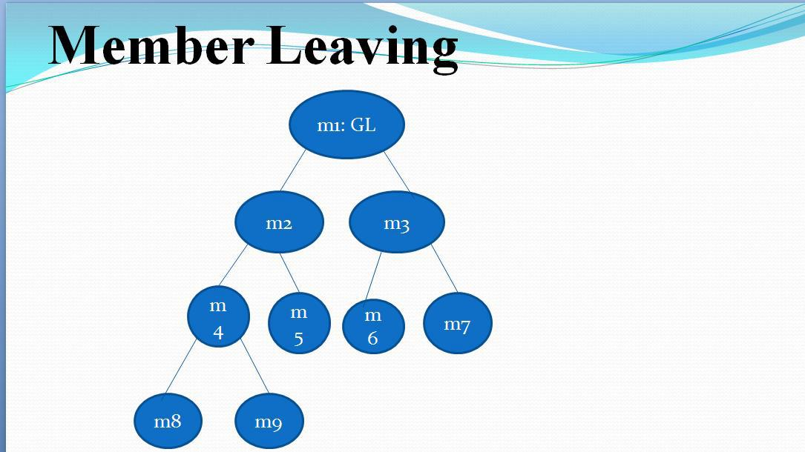
- When a member leave a group then re computation of key take place in this way it preserve backward secrecy

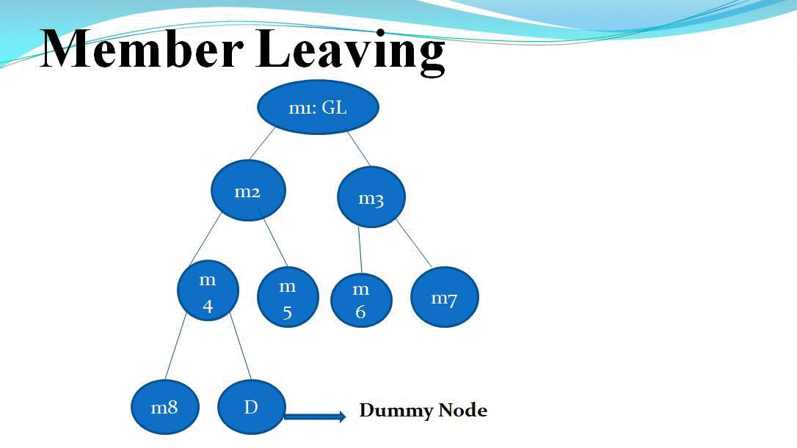

- We are generating key in such a way that each member is participating in the group key generation.

Algo:-1
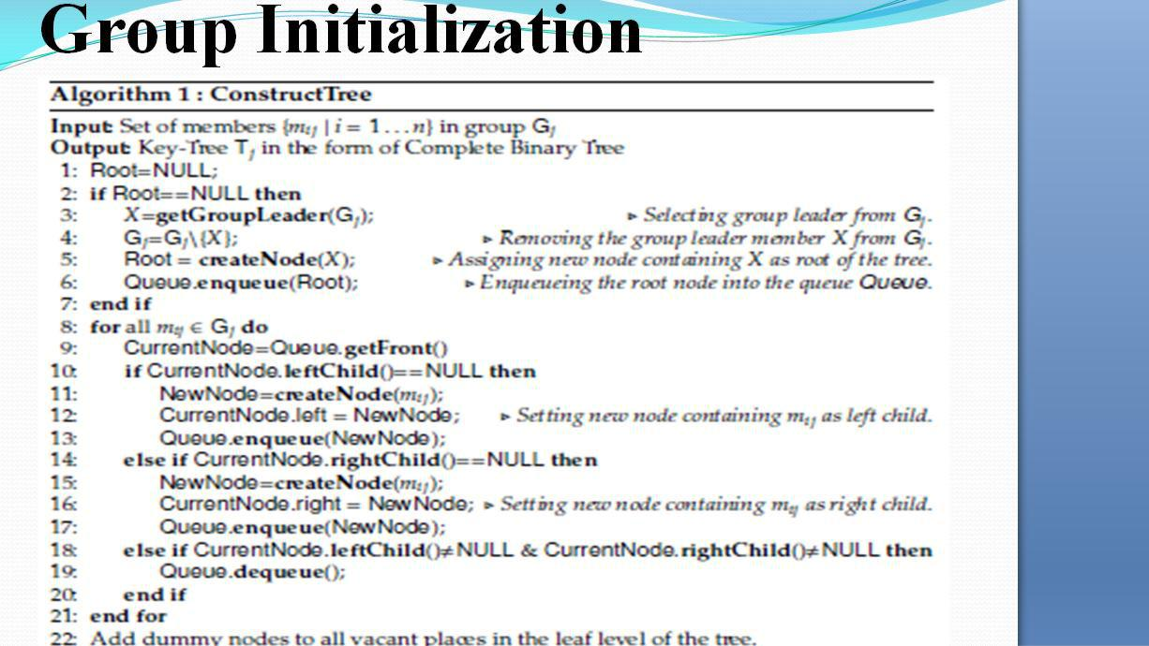
Algo:-2

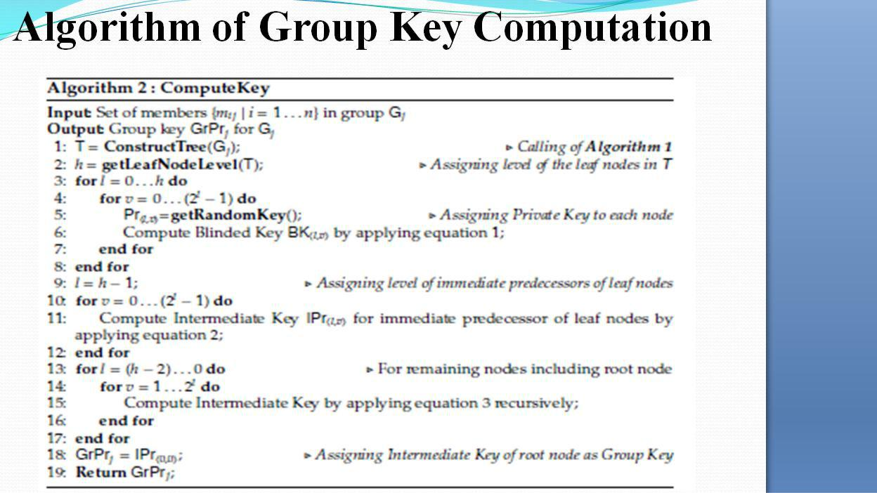

IV.2 Proposed Approach for Multi Group Environment

- In our Proposed approach, Each Group leader has a resource allocation matrix for each member that contains information like which member wants which resource etc.

- The Central Key Distribution Center has all this resource allocation matrice. from all this matrices KDC will separate common member that is is present in two or more groups and inform the group leader about the common member.

- The group leader will generate group key by removing the common member

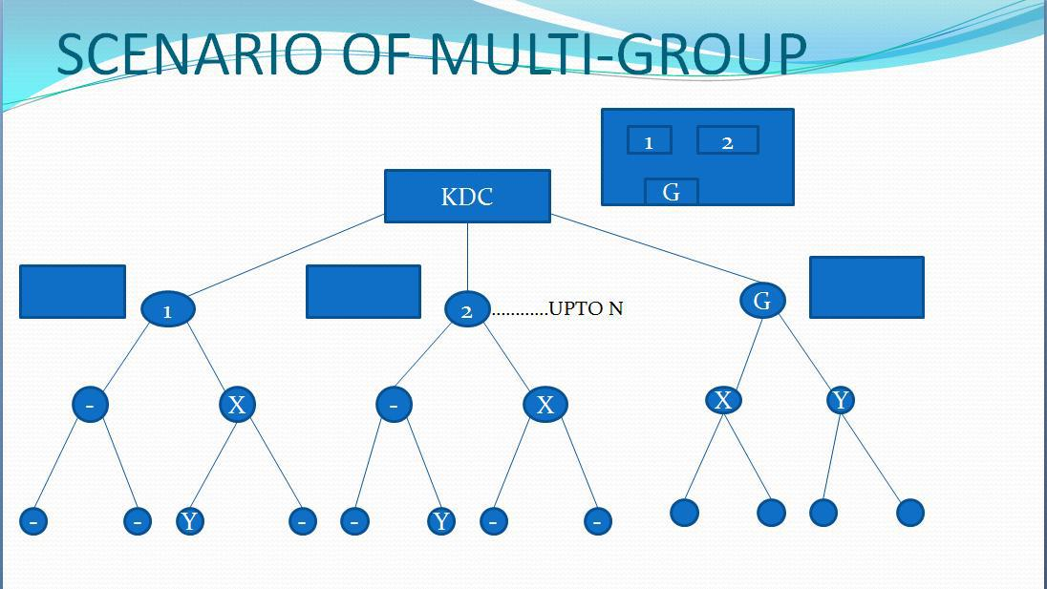
- Each group leader generate group key. KDC generate a group key for common members. By using all group keys one final key is generated. In this key each member has certain contribution.

- Now if one member wants to communicate with other member this member will send a request to Group Leader. Group Leader will see its Resource Matrix Allocation to check whether both the members belongs to same group or not. If both the members belongs to same group then group leader will give right to start communication and now both member will start sharing of data

- If the receiver is not in the same group then Group Leader will
communicate with Group Administrator and Group administrator
will see it’s Matrix and accordingly it will make connection with
the right receiver to communicate. Now both member can start
communication .

V. Software Requirement

- Python environment
- Python 2.7

- Linux server for testing
- Linux based system (Redhat)

VI. Work Done

- Studied the theoretical details of TGDH.

- Went thorough study of different areas of security in Cloud Computing
- Implementing the algorithm for efficient computation of key.

- Analyze the designed algorithm for its efficiency for Single group environment.

- Analyze the designed algorithm for its efficiency for Multi group environment.

VII. RESULT

- After the implementation and analysis of the algorithms proposed here the following results have been obtained successfully. This graph shows the behaviour of designed algorithm .

Comparison of Tree Construction Time:

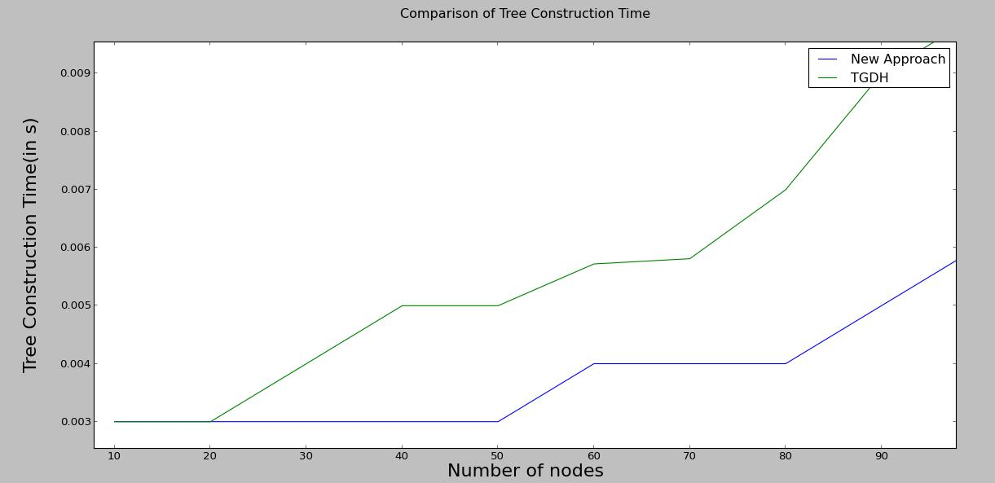

Comparison of Group Key Computation Time

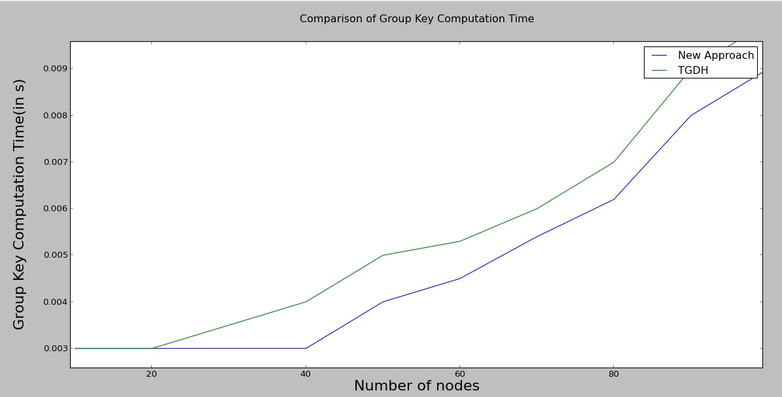

We can see it’s a Linear Algorithm

VIII. Future Work

We have to implement and analyze the proposed algorithm of Multi group Key Management.
IX. Conclusion

- Our proposed algorithm for Single Group performs well as compared to the others proposed algorithms. It is more efficient with respect to Key computation. It is scalable in real time application. It uses the resources optimally.

- Our proposed algorithm for multi group environment is more efficient as it reduces the overhead of computing the same member that is present in more than one group.

- It helps to securely communicate in Multi Group Environment.

X. References

- Goyal, V., Tripathy, R.: An ecient solution to the arp cache poisoning problem. In: Australasian Conference on Information Security and Privacy. 40–51. Springer(2005).

- H., K., B., C.R., J., S.: Novel defense mechanism against data flooding attacks inwireless ad hoc networks. IEEE Transactions on Consumer Electronics 56(2), 579–582 (2010).

- Kahate, A.: Cryptography and Network Security. McGraw Hill Education (India) Private Limited (2016).

- Khan, A.N., Kiah, M.M., Madani, S.A., Ali, M., Shamshirband, S., et al.: Incremental proxy re-encryption scheme for mobile cloud computing environment. The Journal of Supercomputing 68(2), 624–651 (2014).

- Kim, Y., Perrig, A., Tsudik, G.: Tree-based group key agreement. ACM Transactions on Information and System Security (TISSEC) 7(1), 60–96 (2004).

- M., A., R., D., E., K., U., K.S., V., V.A., K., L., y., Z.A.: Sedasc: Secure data sharing in clouds. IEEE Systems Journal PP(99), 1–10 (2015).

- Modi, C., Patel, D., Borisaniya, B., Patel, A., Rajarajan, M.:Asurvey on security issues and solutions at dierent layers of cloud computing. The Journal of Supercomputing 63(2), 561–592 (2013).

- Paterson, K.G., Quaglia, E.A.: Time-specific encryption. In: International Conference on Security and Cryptography for Networks.

1–16. Springer (2010).

- R., A., B.B., A.: Key management scheme for multiple simultaneous secure group communication. In: 2009 IEEE International Conference on Internet Multimedia Services Architecture and Applications (IMSAA). 1–6 (Dec 2009).

